**LAB 3 – Vũ Minh Dũng 20205179**

Contents

**1.** **Re-organize the project** 2

**2.** **Update the Cart class and CartTest class** 4

**3.** **Implement the Store class** 5

**4.** **String, StringBuilder and StringBuffer** 6

**5.** **Implementation of the Book class** 8

**6.** **Implementation of the abstract Media class** 9

**7.** **Implementation of the CompactDisc class** 10

**8.** **Implementation of the Playable interface** 12

**9.** **Updating the Cart class to work with Media** 14

**10.** **Updating the Store class to work with Media** 16

**11.** **Polymorphism with toString method** 17

**12.** **Sort media in the cart** 18

**13.** **Create a complete console application in the Aims class** 20

Figure 1: Cart class after updating 4

Figure 2: CartTest class after updating and running 4

Figure 3: Store class after implementing 5

Figure 4: StoreTest class after implementing and running 5

Figure 5: ConcatenationInLoops class 6

Figure 6: GarbageCreator class 6

Figure 7: NoGabage class 7

Figure 8: Book class 8

Figure 9: Media class 9

Figure 10: Disc class 10

Figure 11: DigitalVideoDisc extends Disc 10

Figure 12: Track class 11

Figure 13: Updating CompactDisc class 11

Figure 14: Playable interface 12

Figure 15: Updating play() method in CompactDisc, DigitalVideoDisc, Track 13

Figure 16: Updating Cart class 15

Figure 17: Store class after updating 16

Figure 18: toString and equals 17

Figure 19: Implementing two comparator 19

# **Re-organize the project**

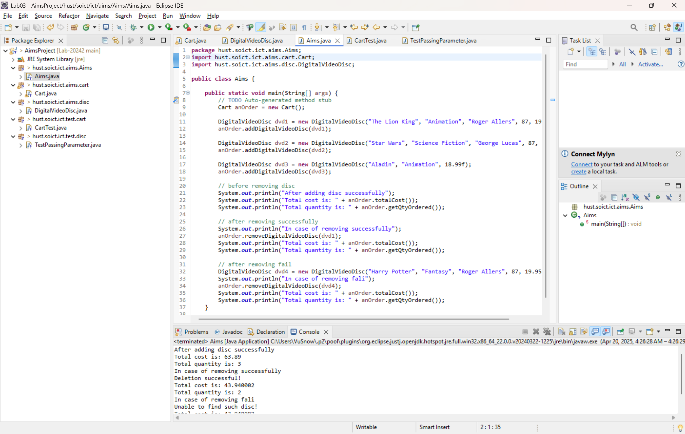

* After re-organizing, the structure of the project like the above image

# **Update the Cart class and CartTest class**

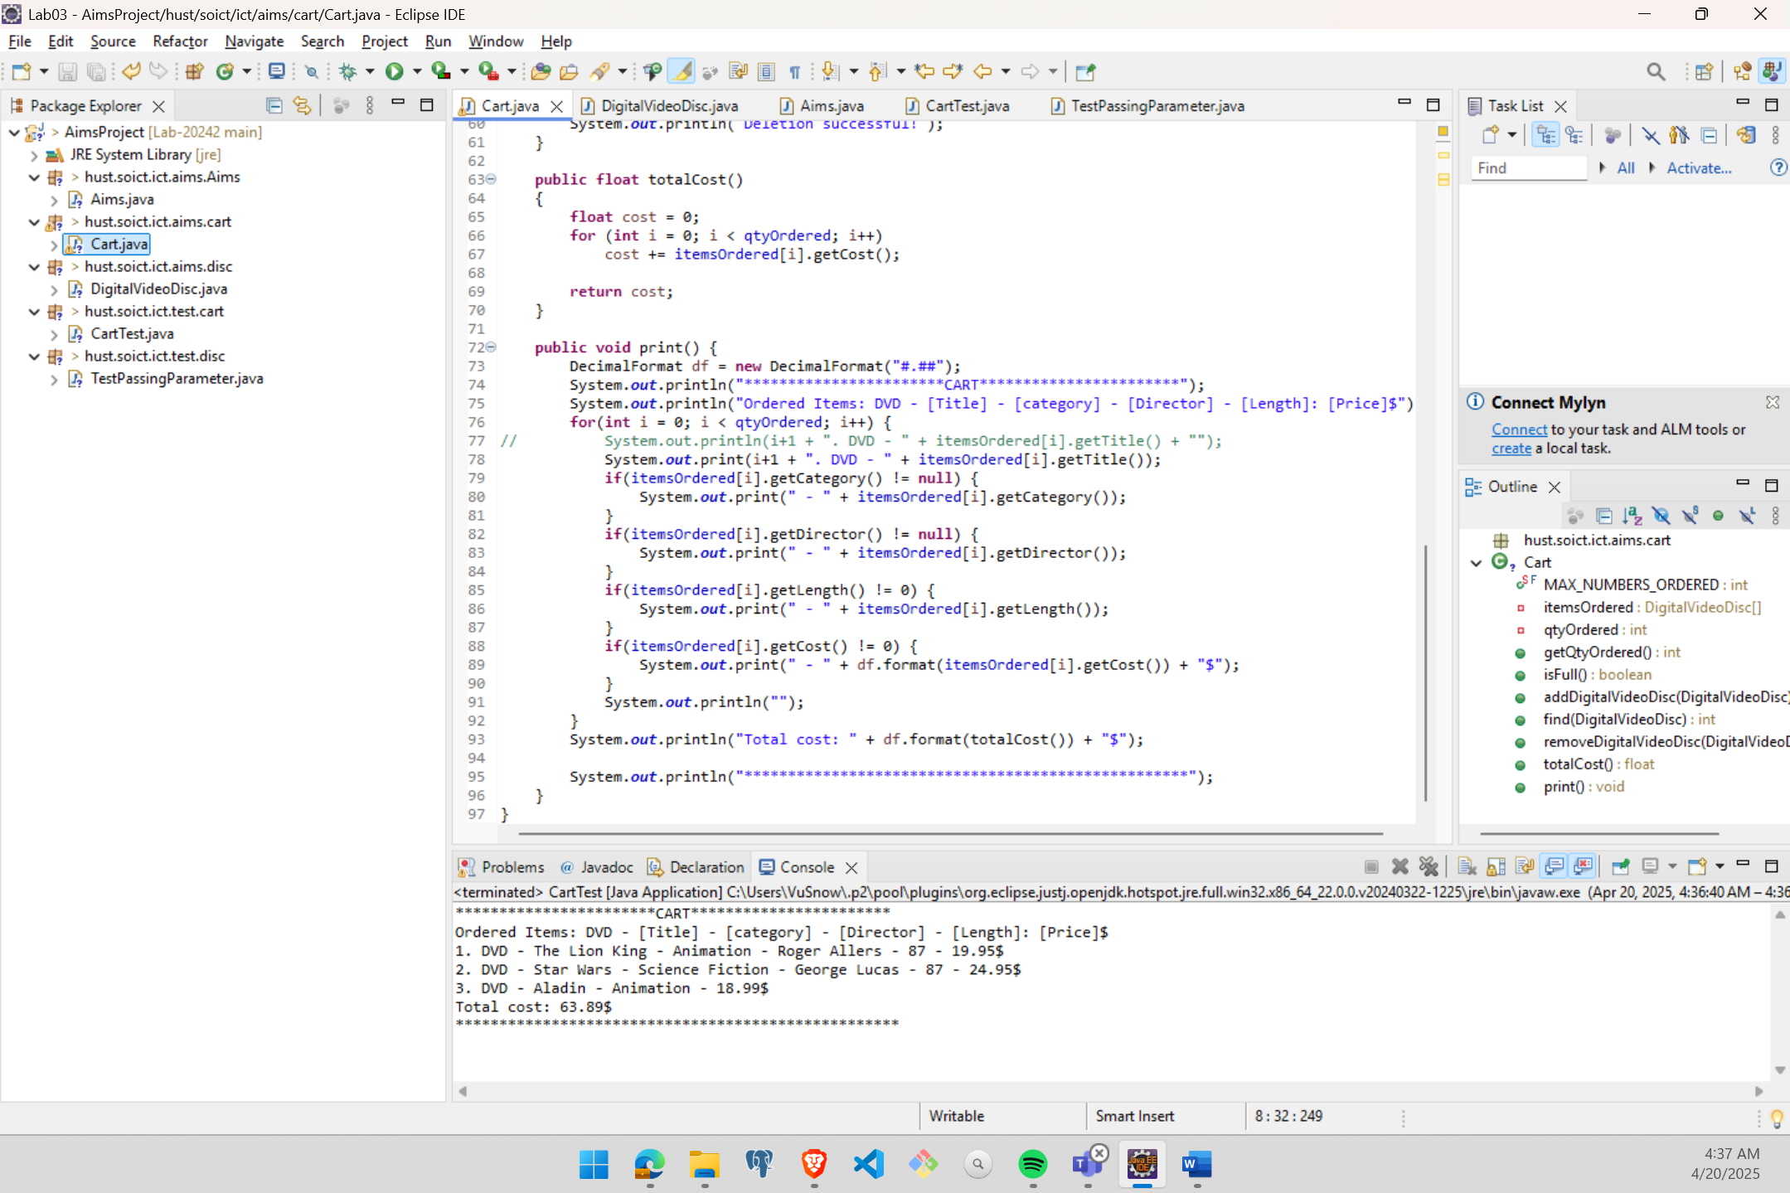

Figure : Cart class after updating

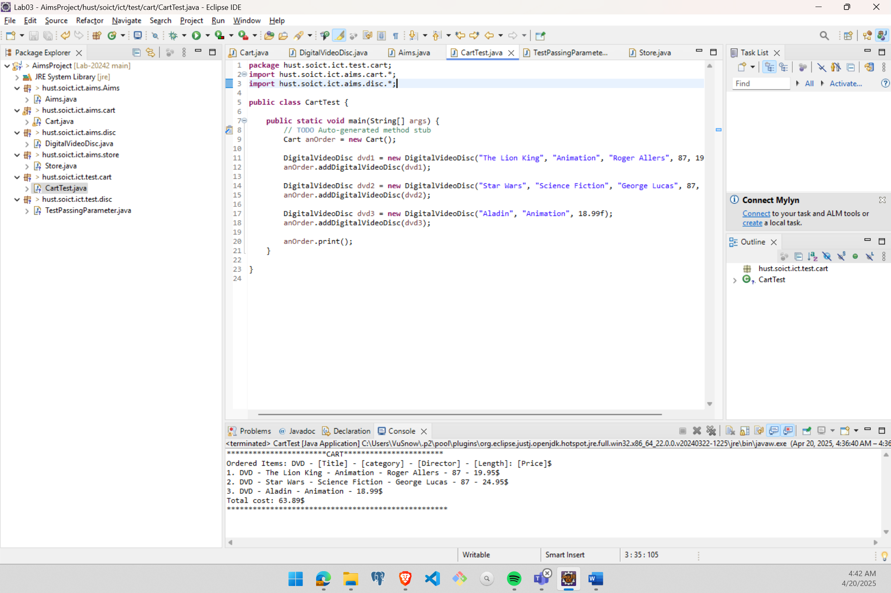

Figure : CartTest class after updating and running

# **Implement the Store class**

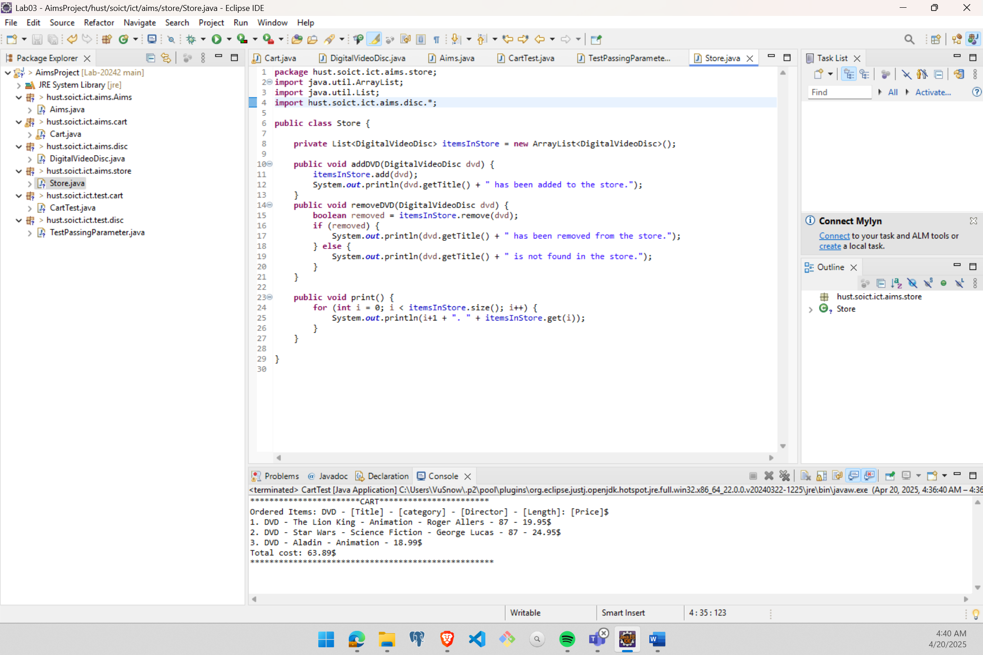

Figure : Store class after implementing

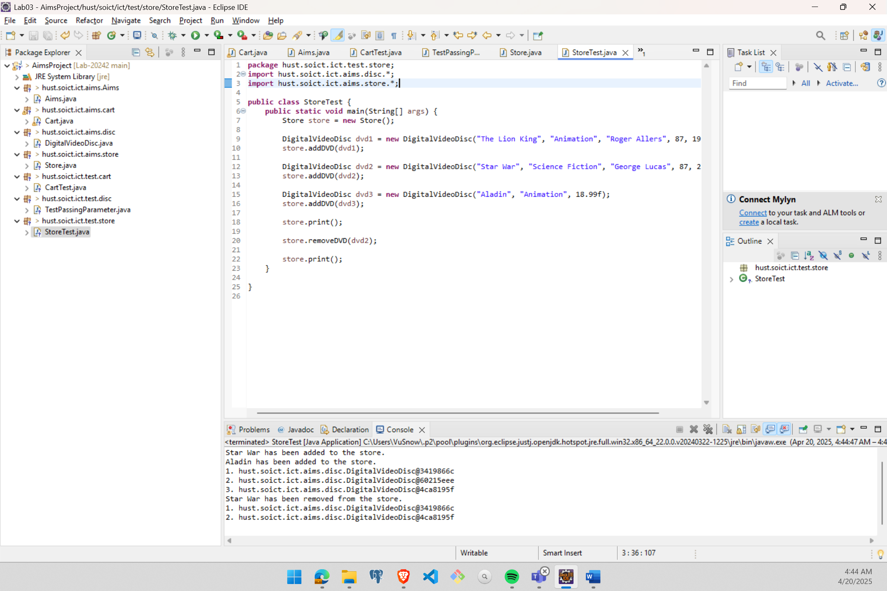

Figure : StoreTest class after implementing and running

# **String, StringBuilder and StringBuffer**

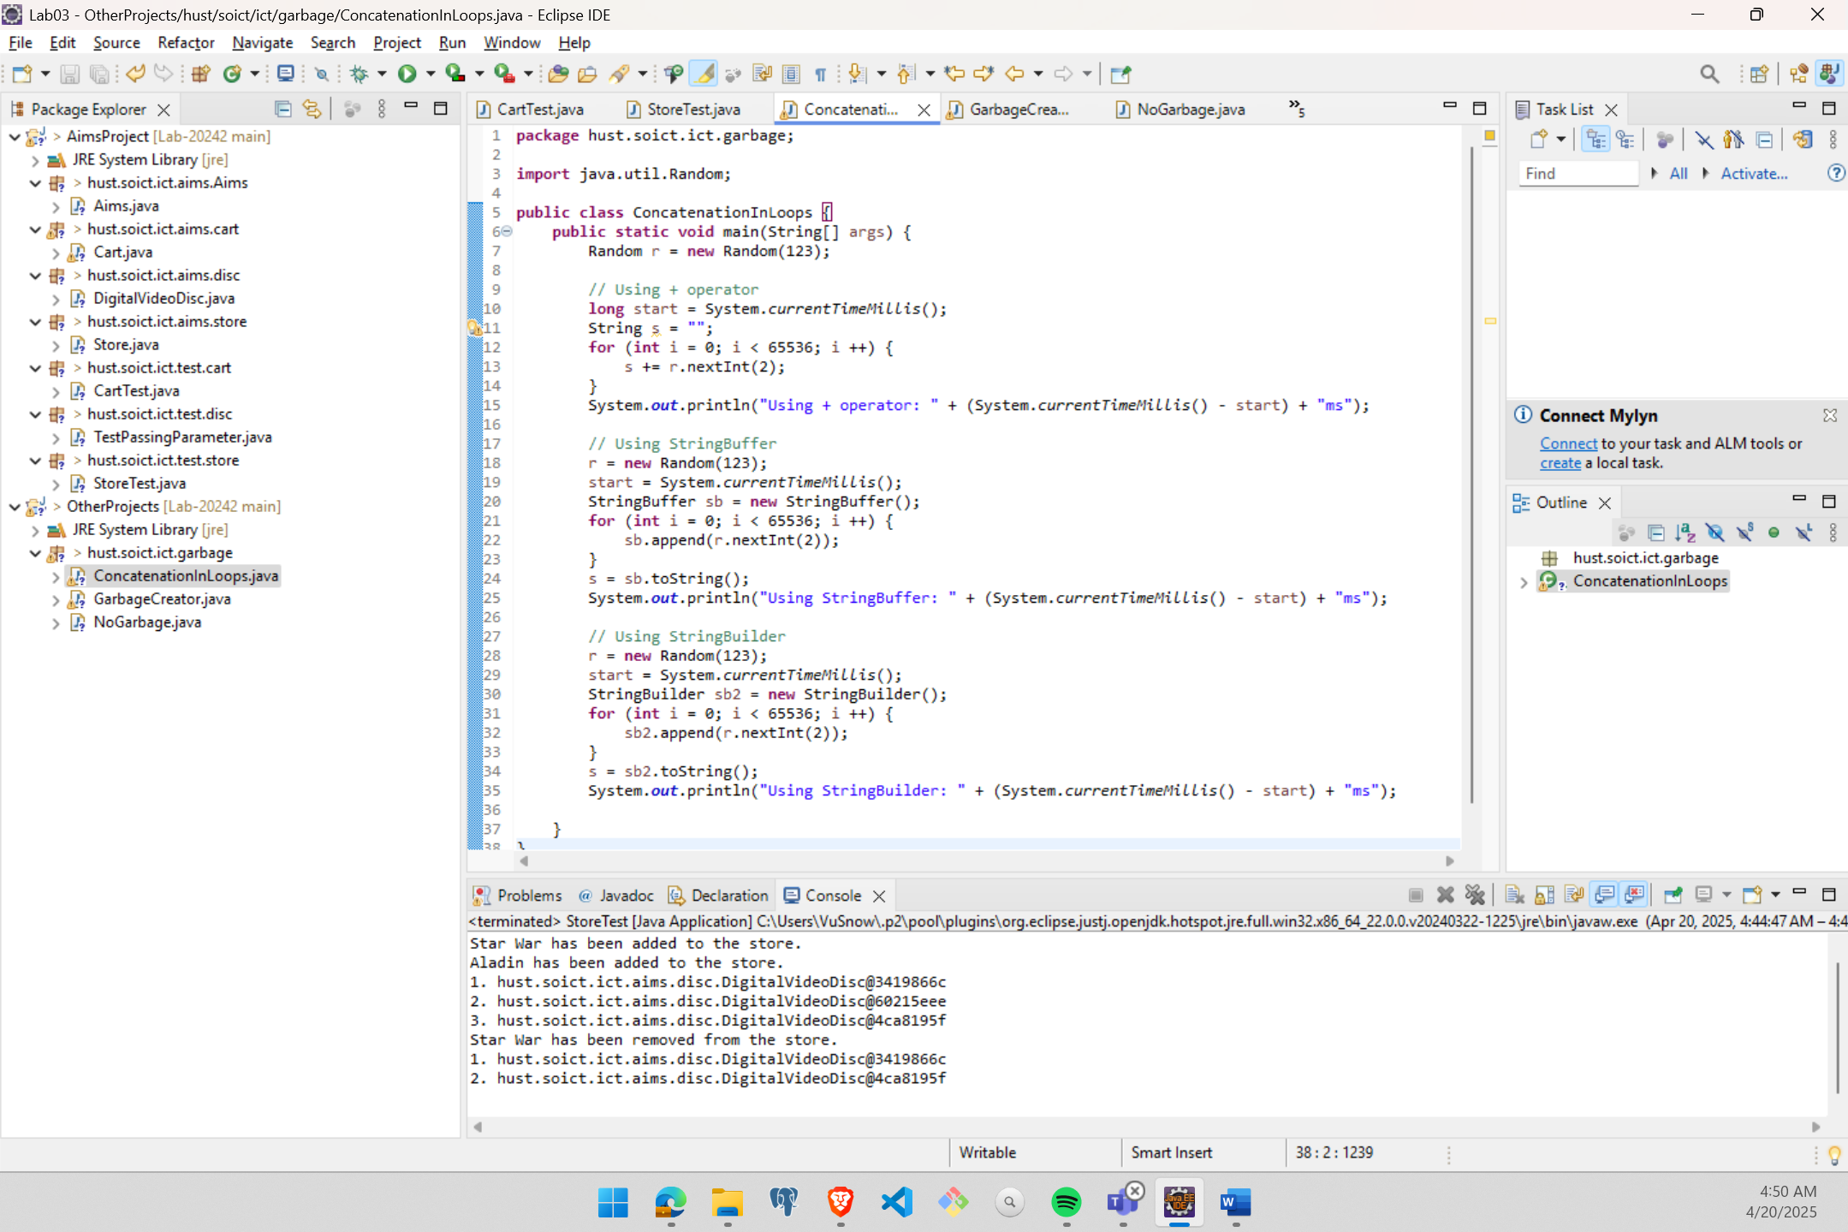

Figure : ConcatenationInLoops class

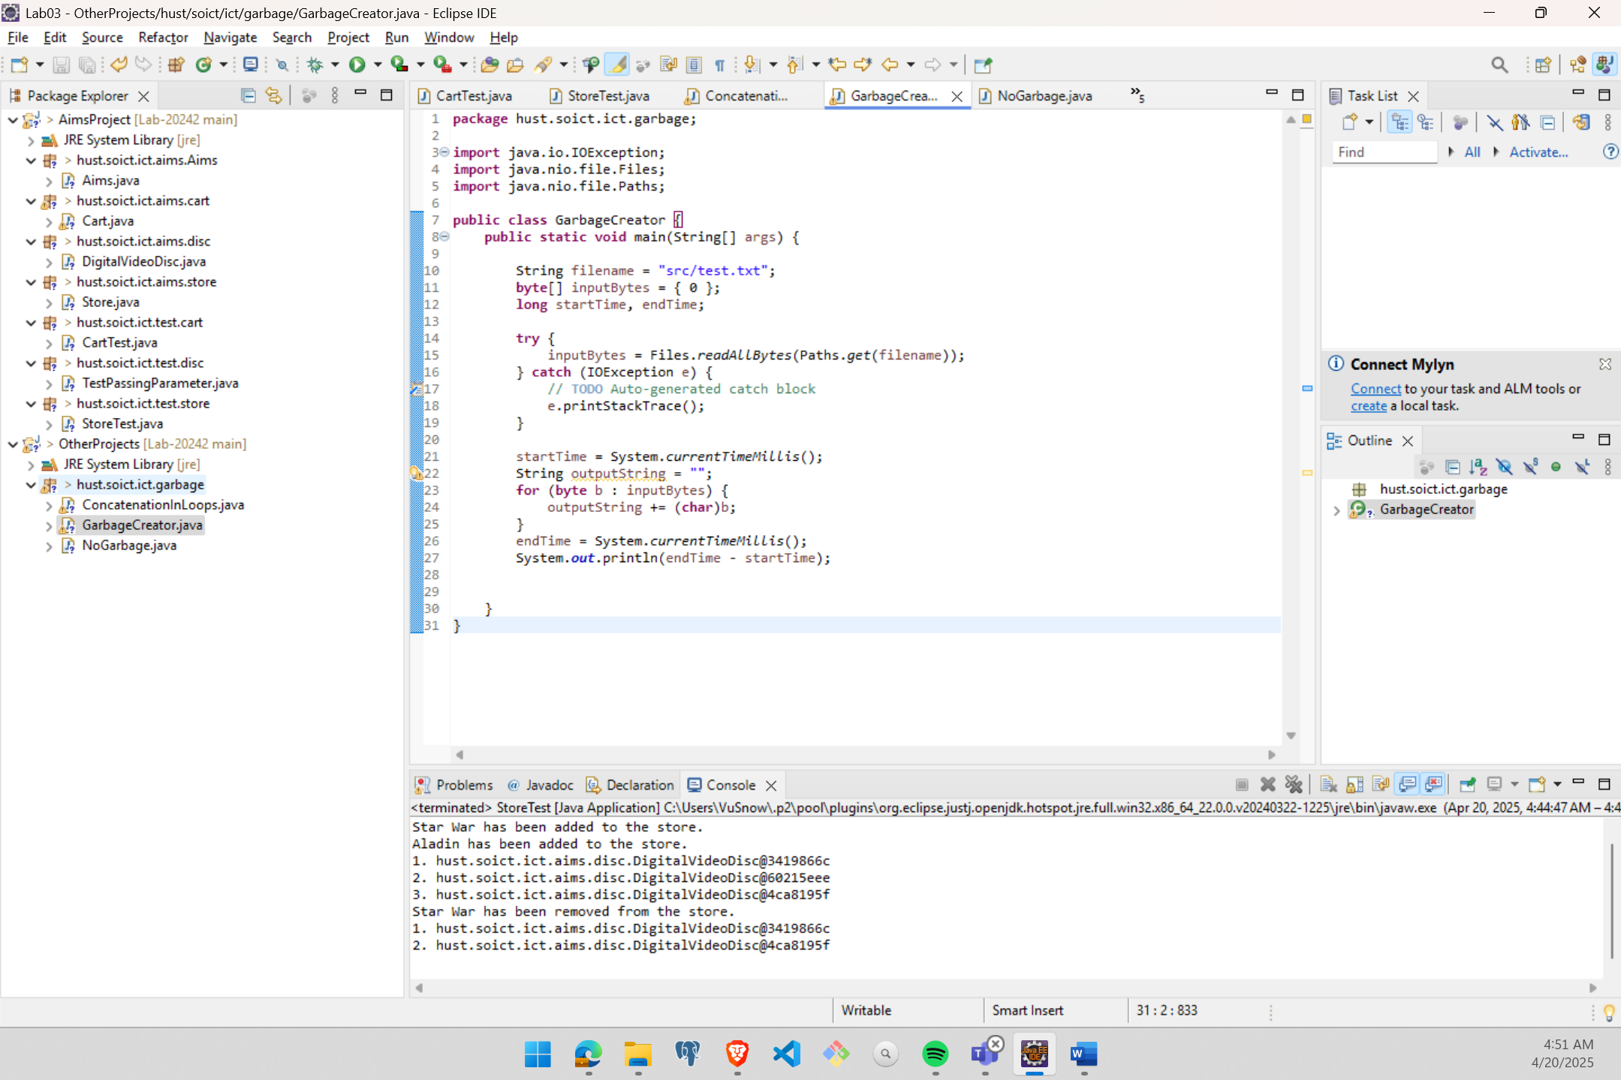

Figure : GarbageCreator class

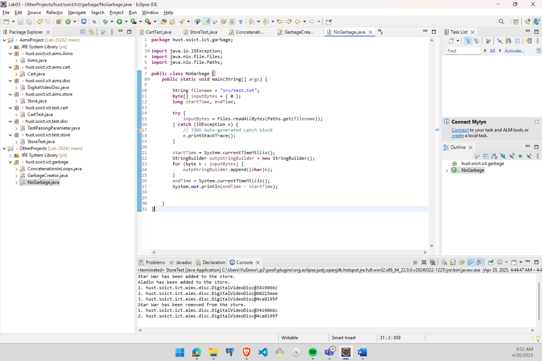

Figure : NoGabage class

# **Implementation of the Book class**

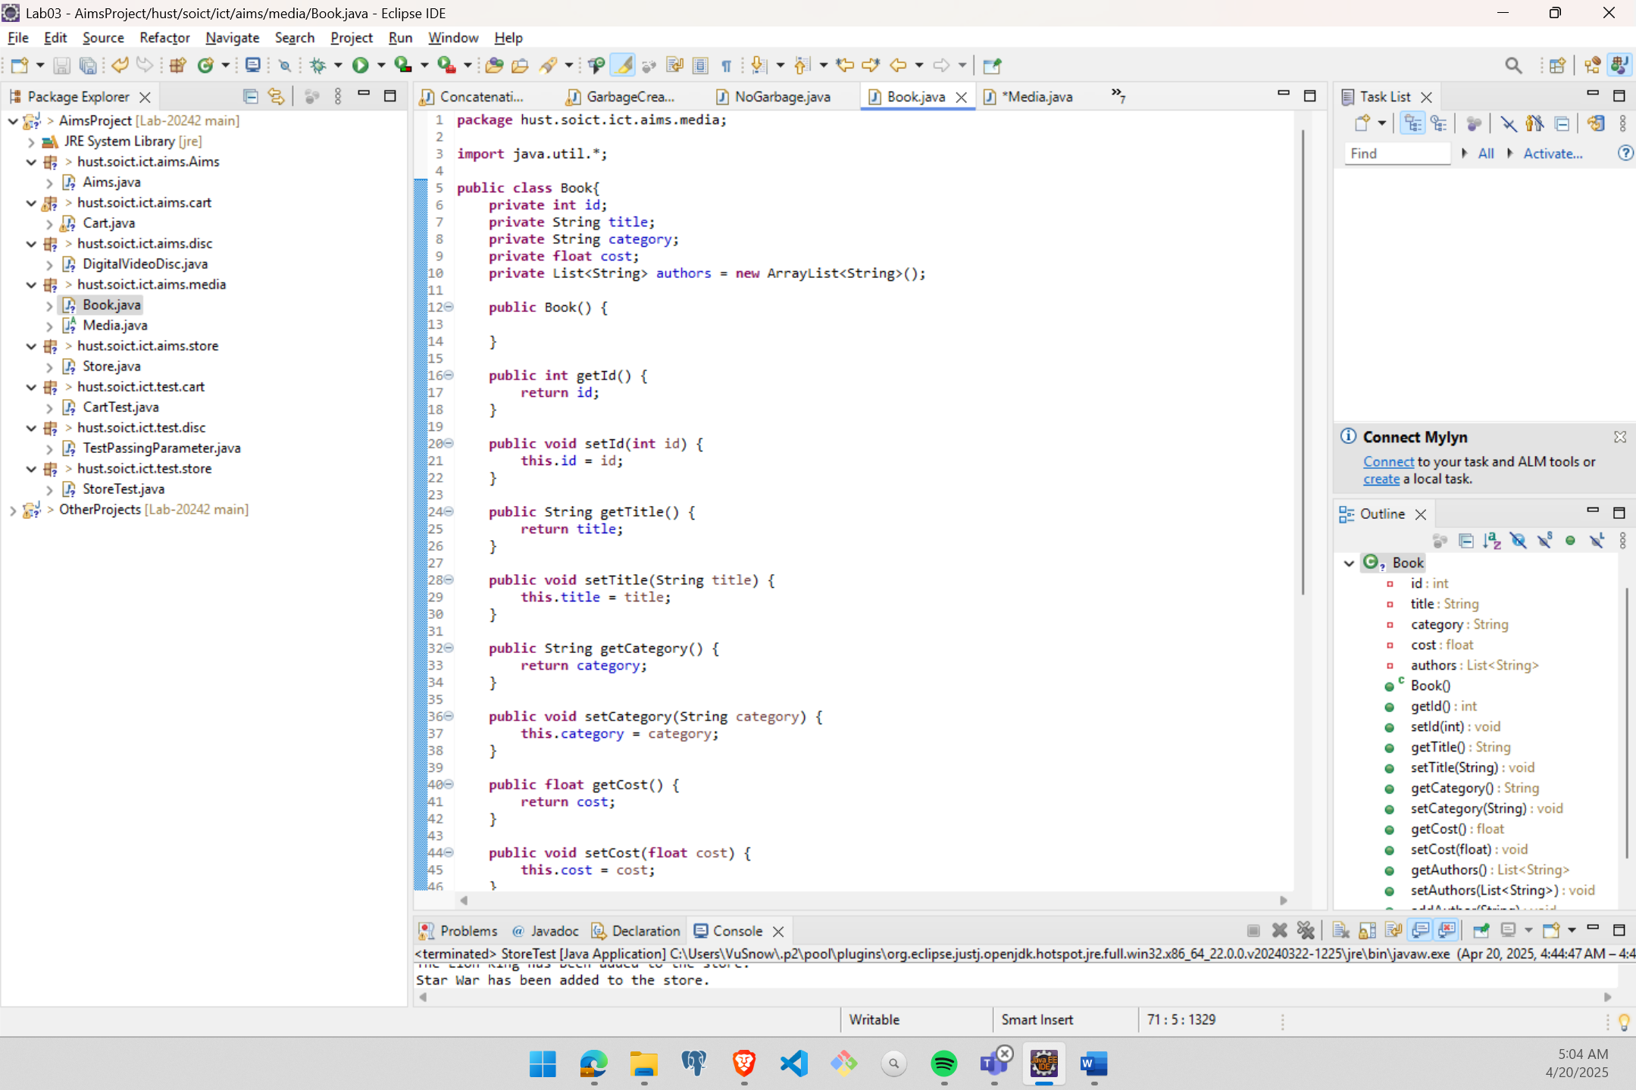

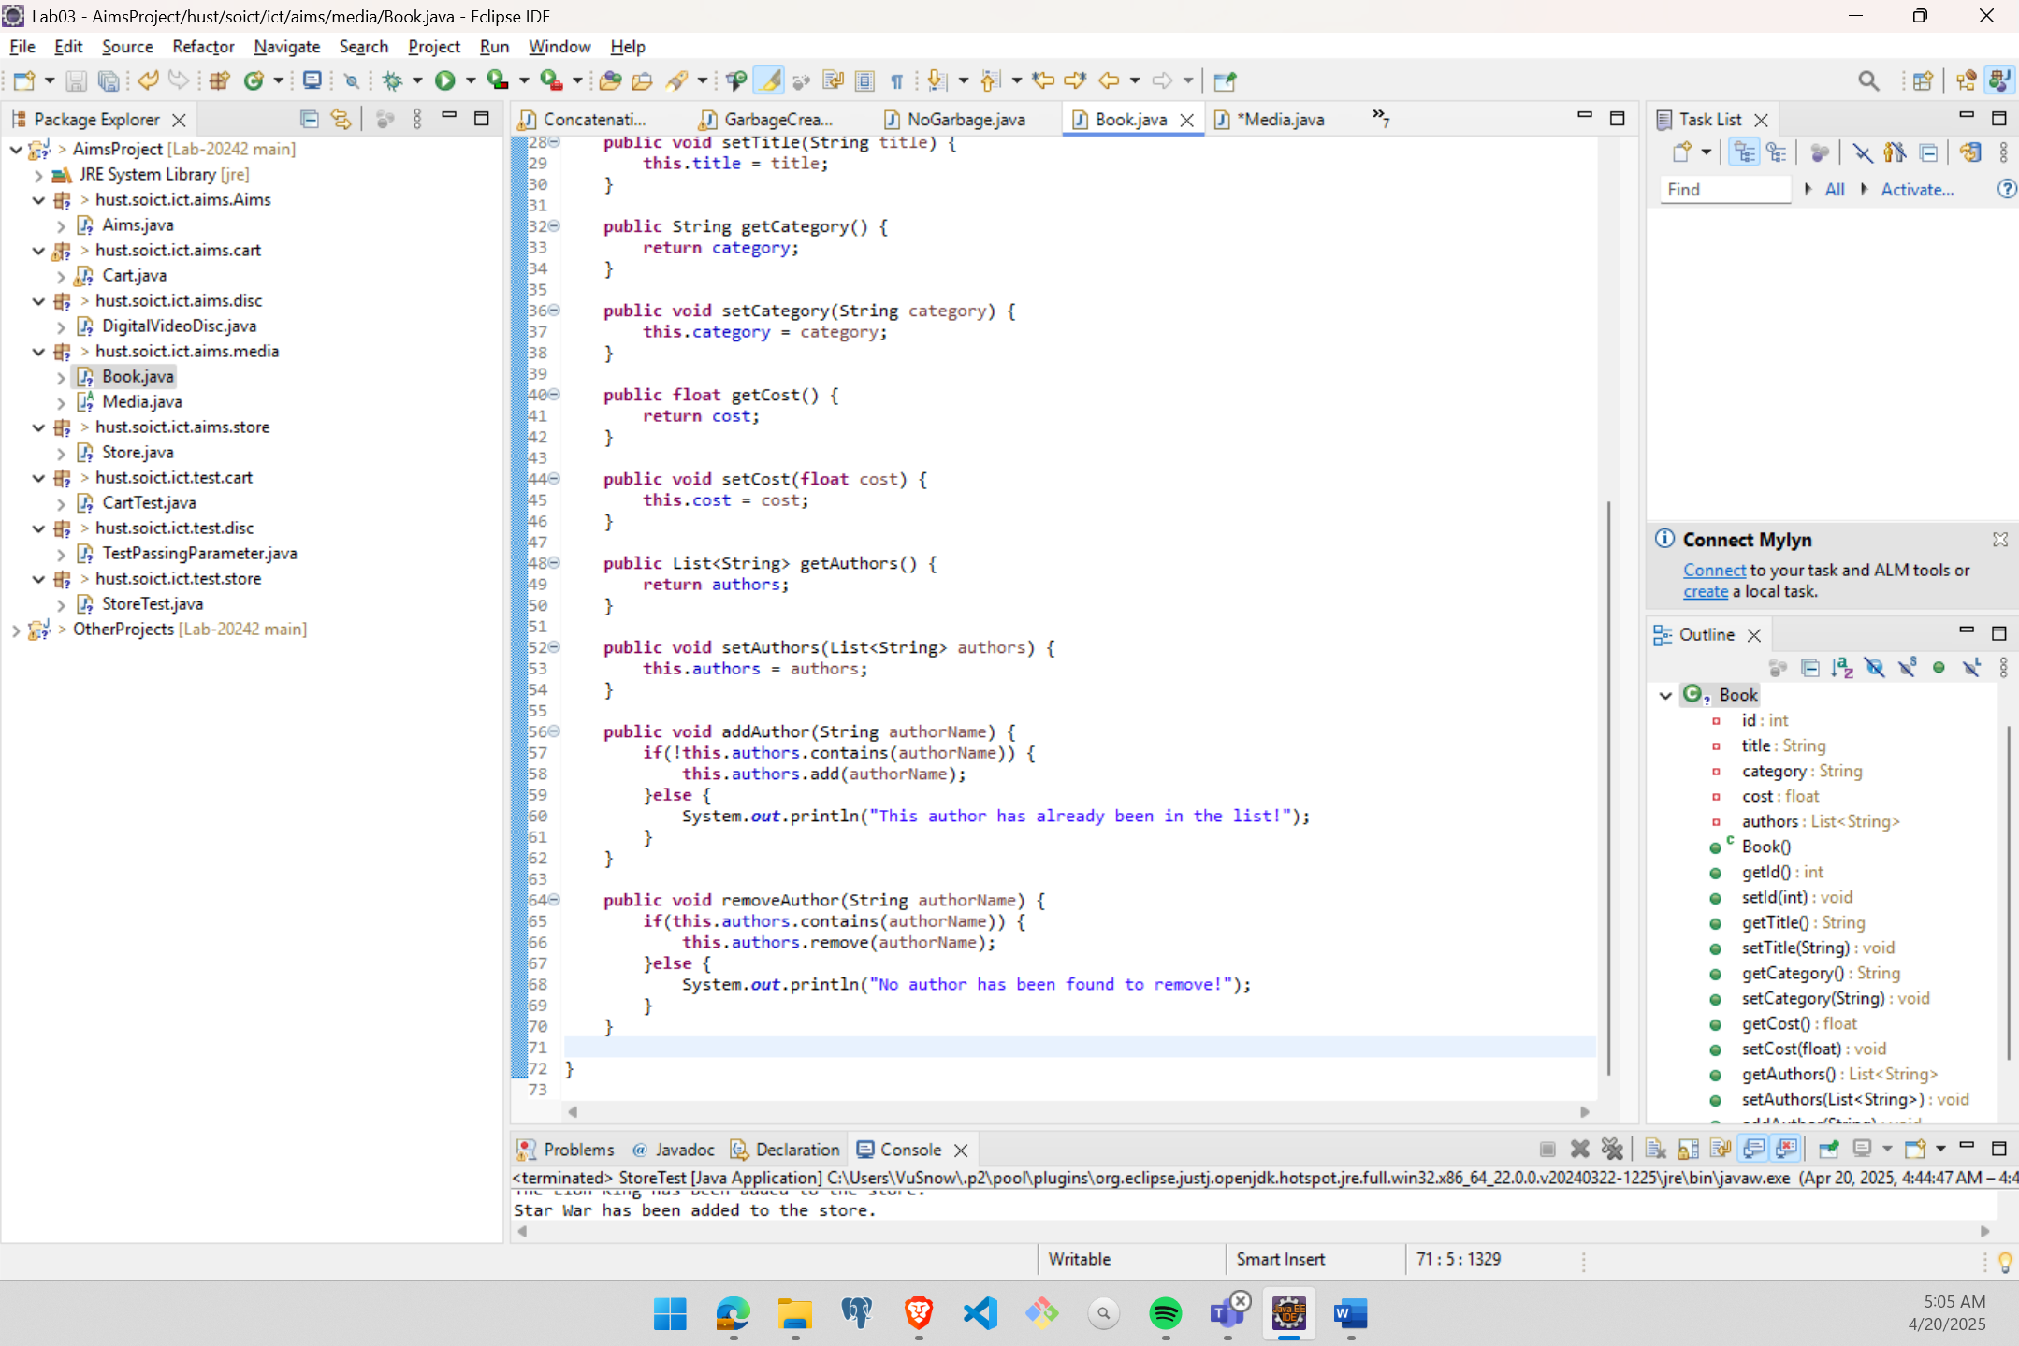

Figure : Book class

# **Implementation of the abstract Media class**

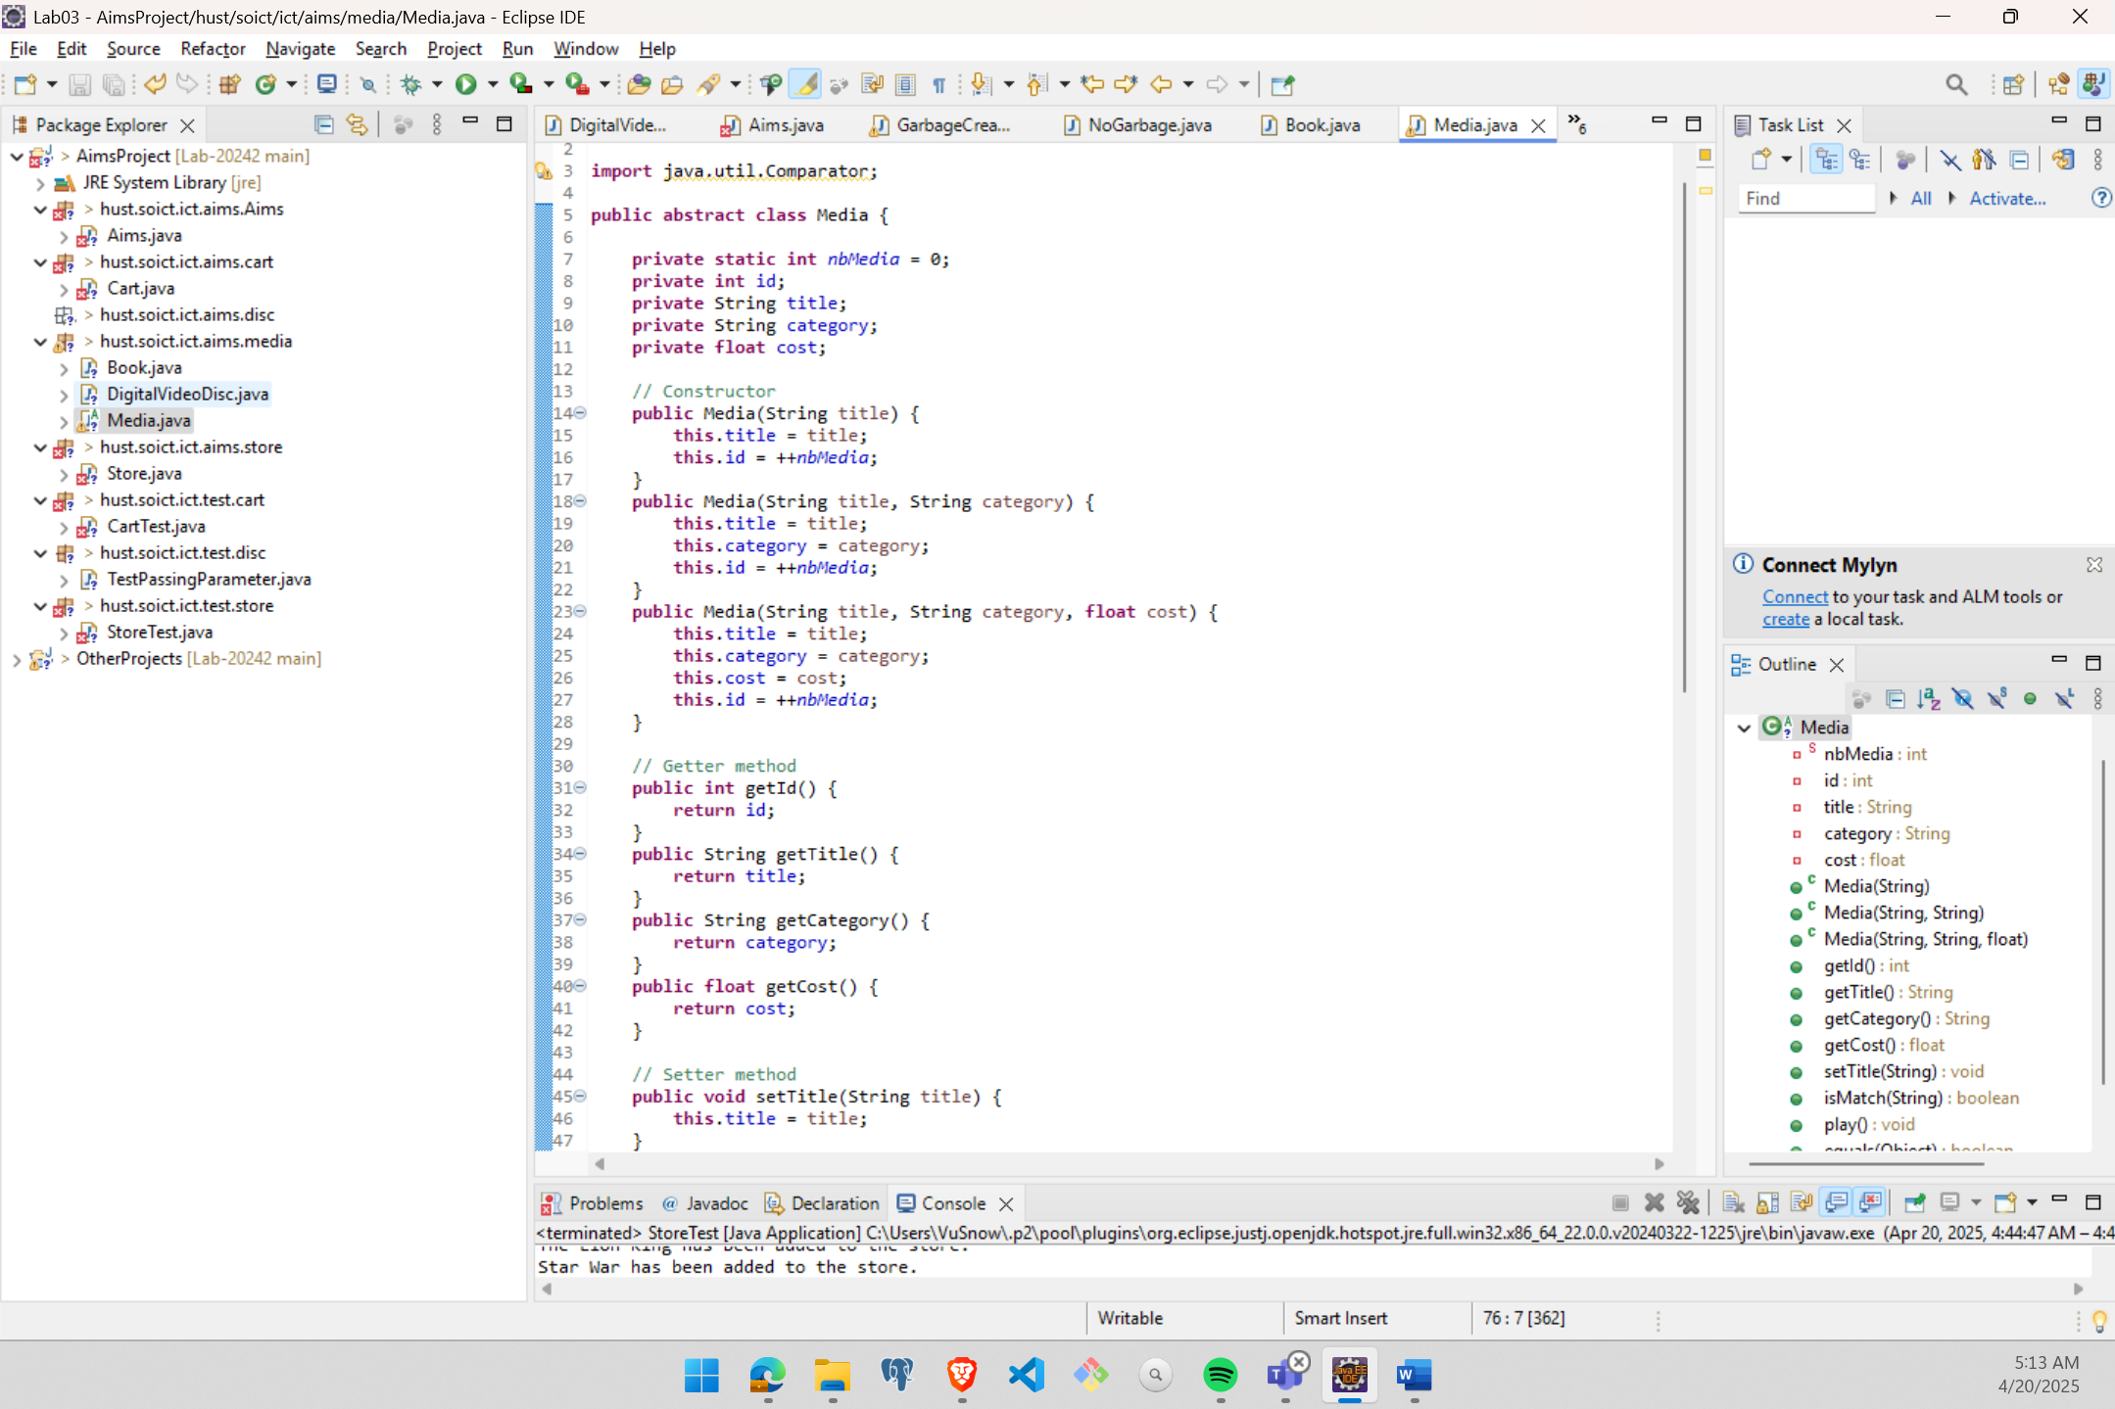

Figure : Media class

# **Implementation of the CompactDisc class**

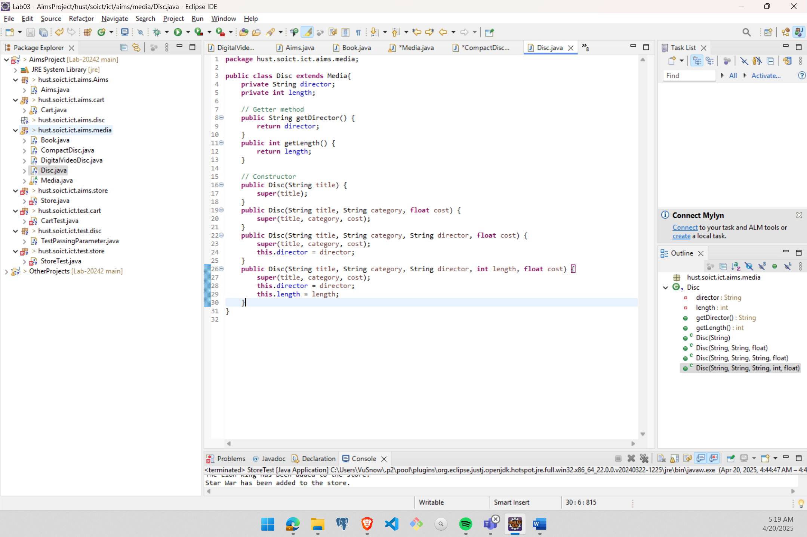

Figure : Disc class

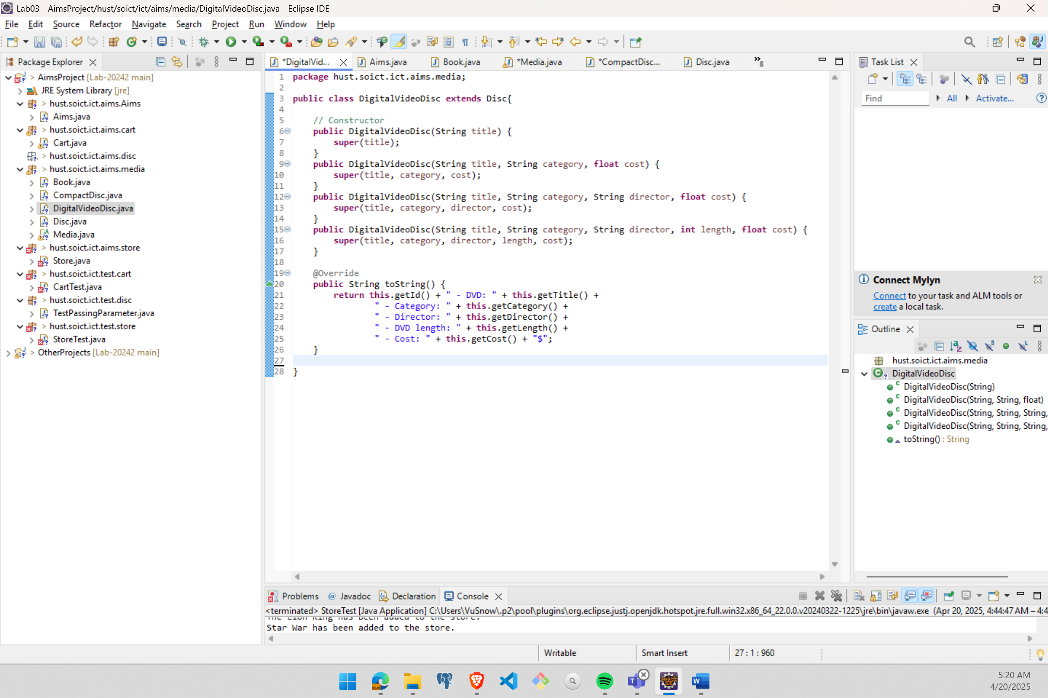

Figure : DigitalVideoDisc extends Disc

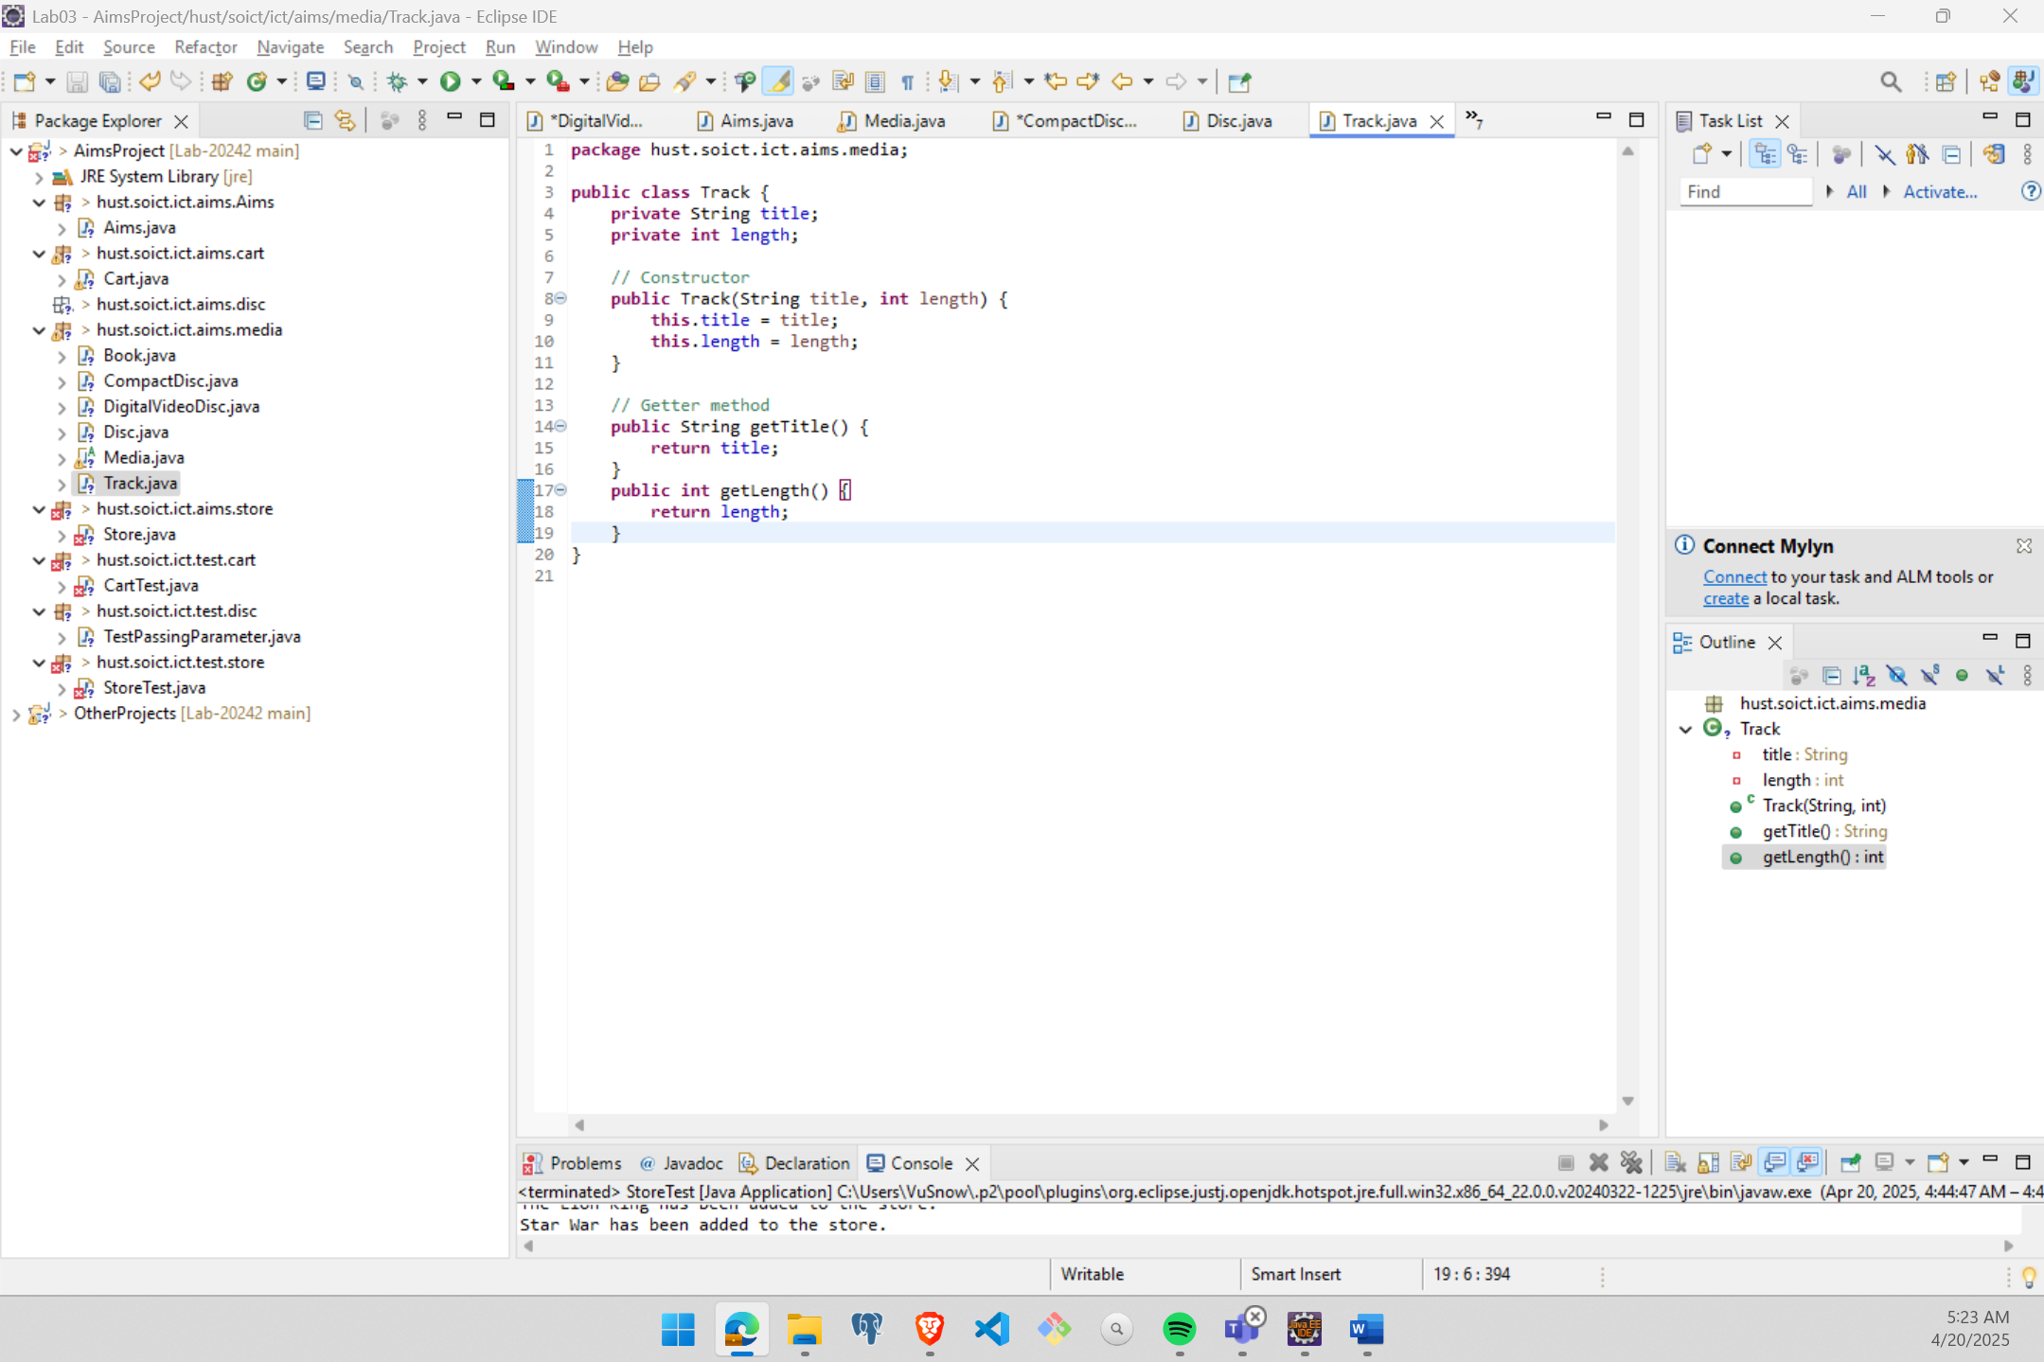

Figure : Track class

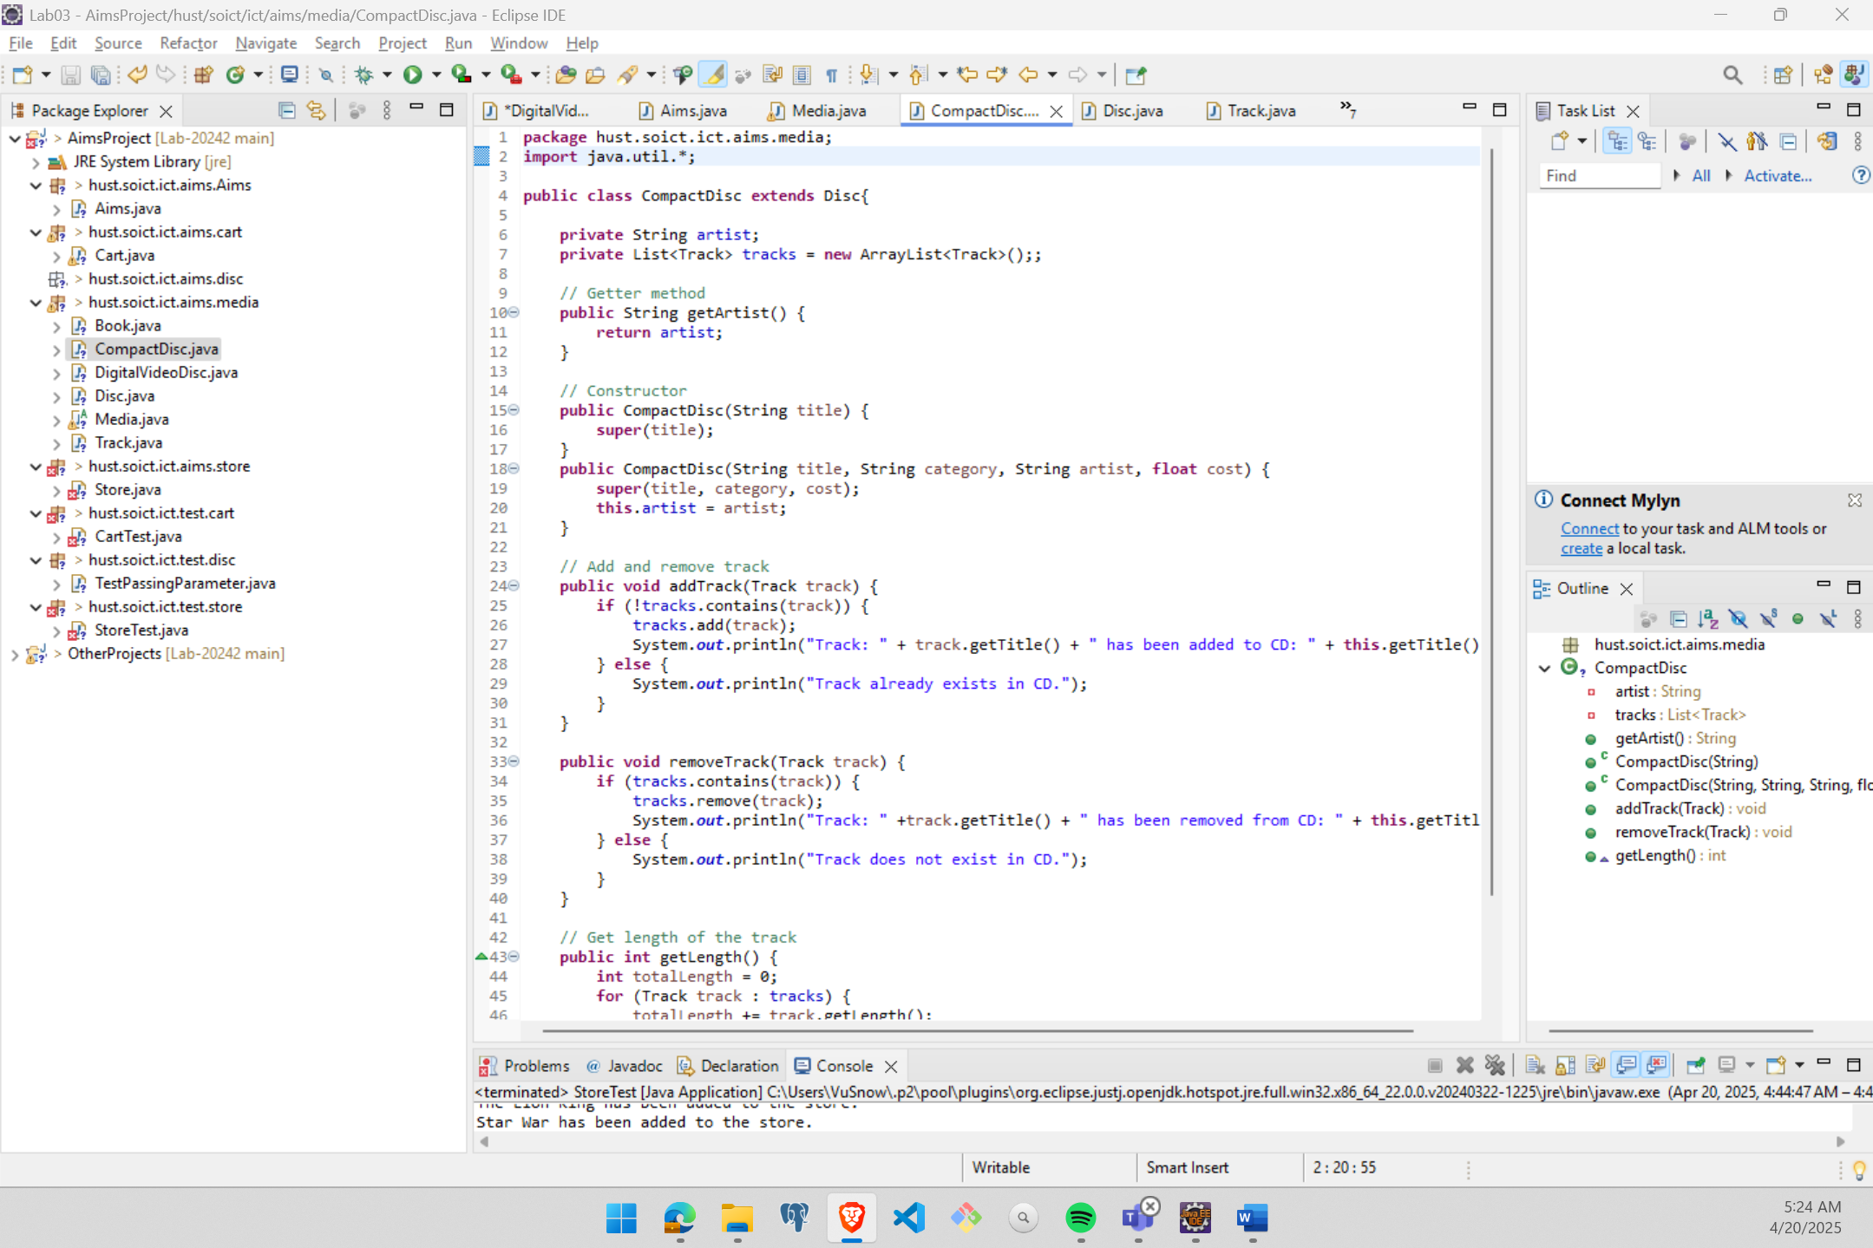

Figure : Updating CompactDisc class

# **Implementation of the Playable interface**

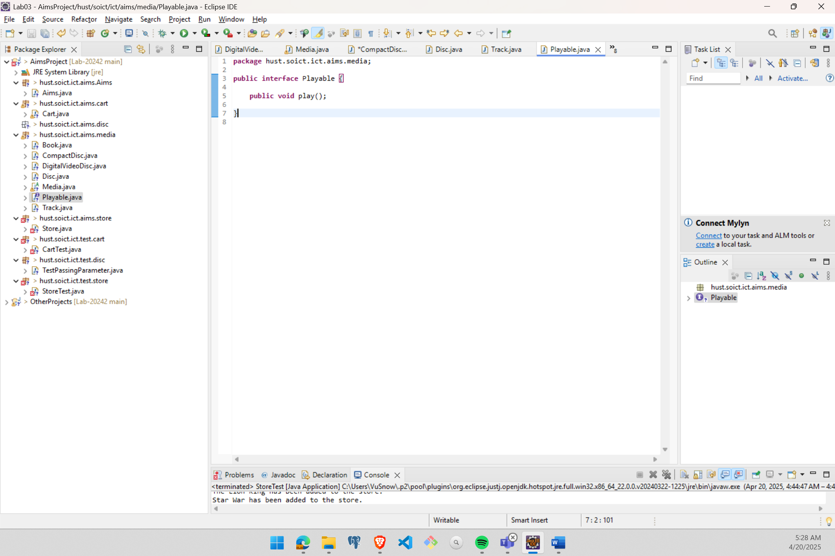

Figure : Playable interface

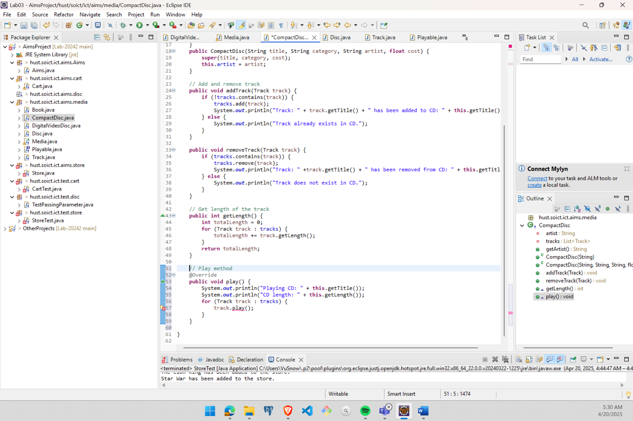

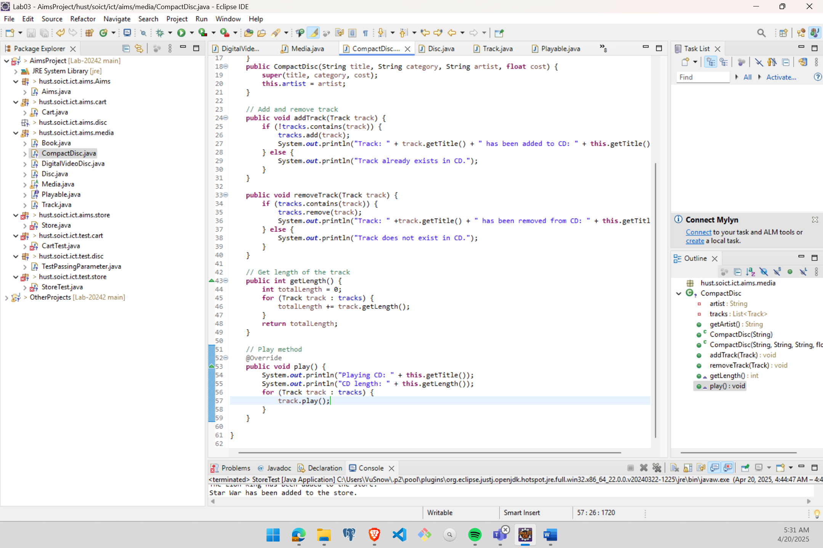

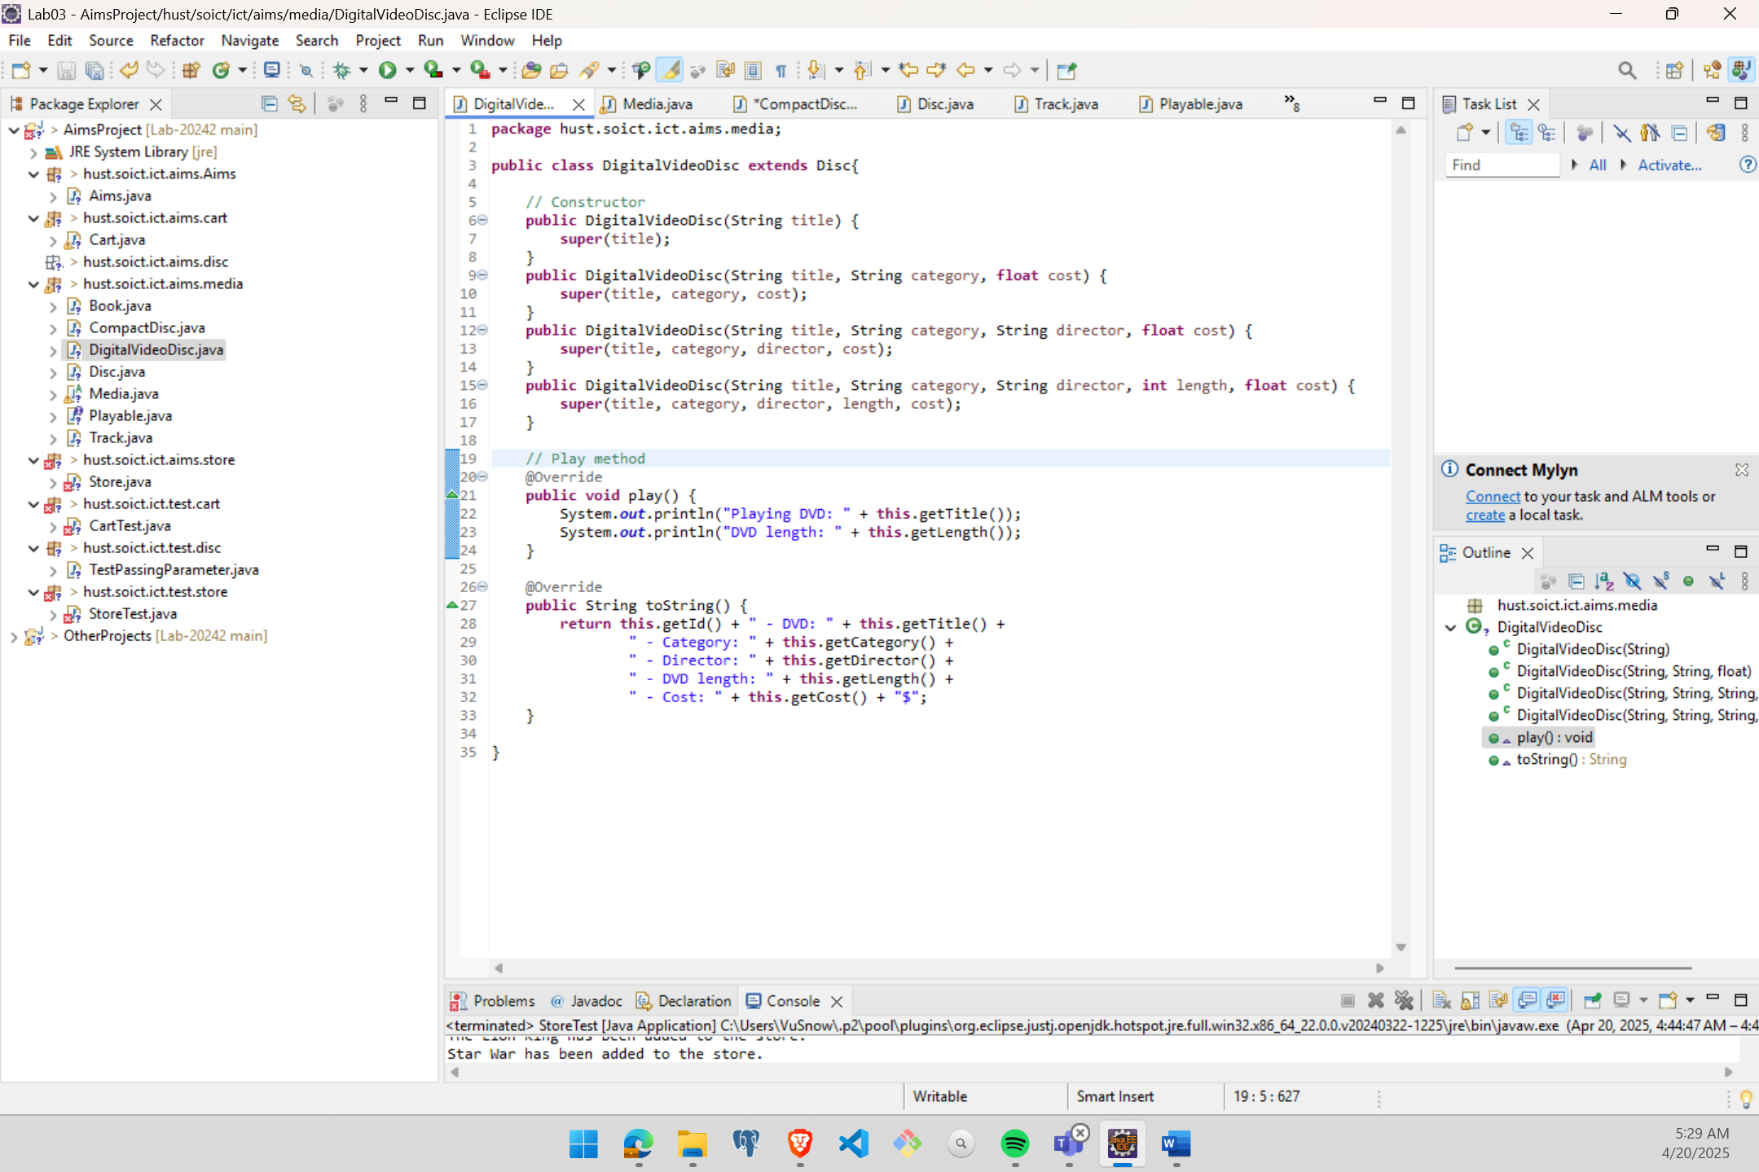

Figure : Updating play() method in CompactDisc, DigitalVideoDisc, Track

# **Updating the Cart class to work with Media**

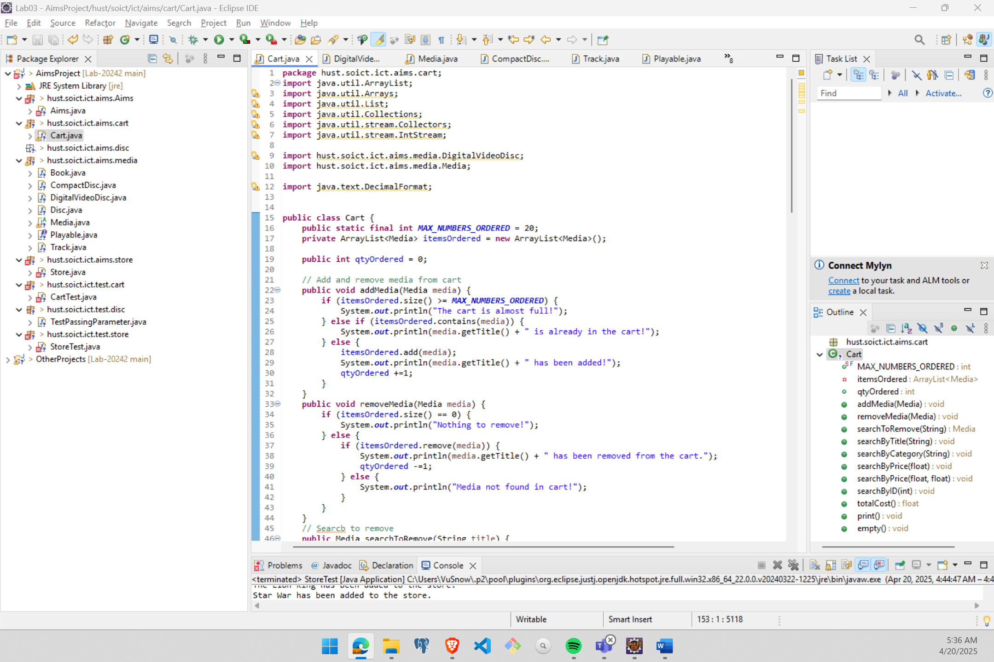

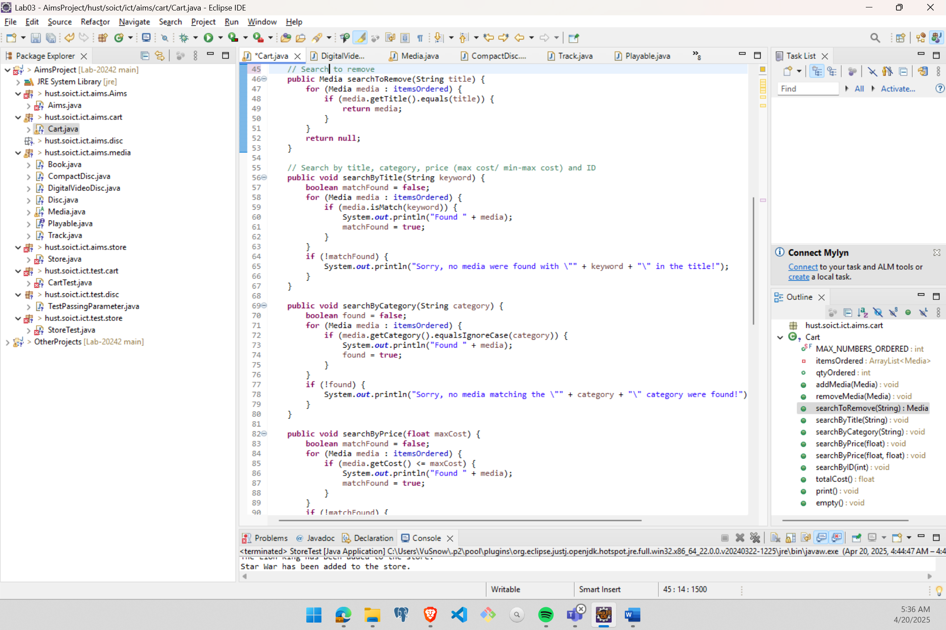

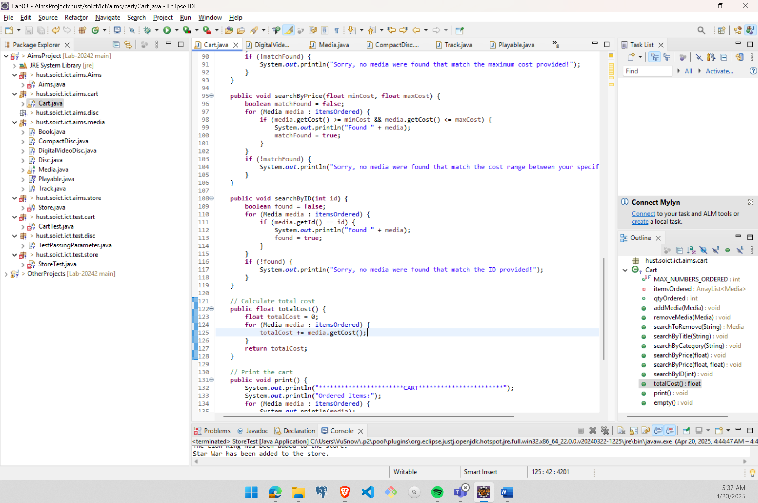

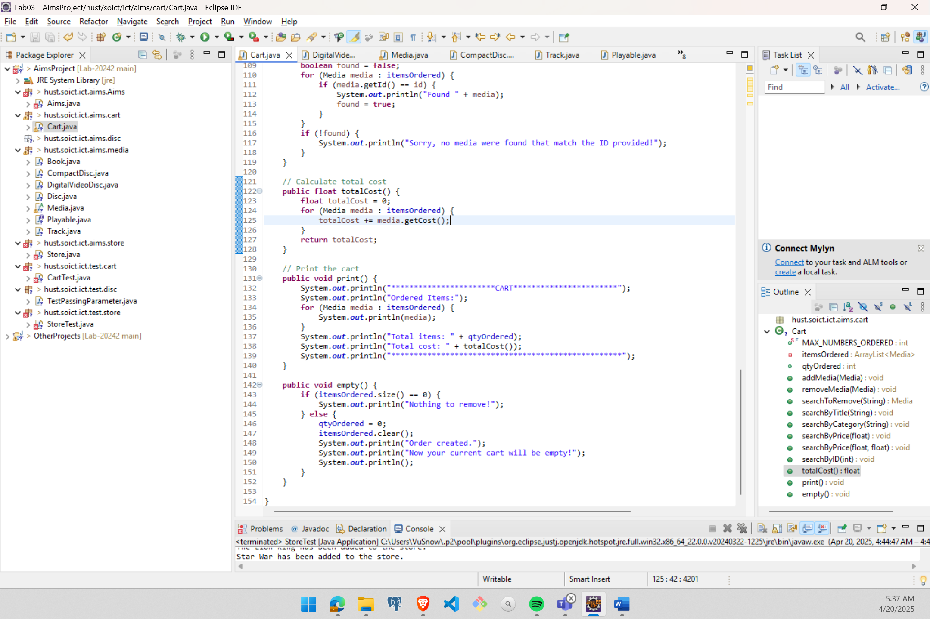

Figure : Updating Cart class

# **Updating the Store class to work with Media**

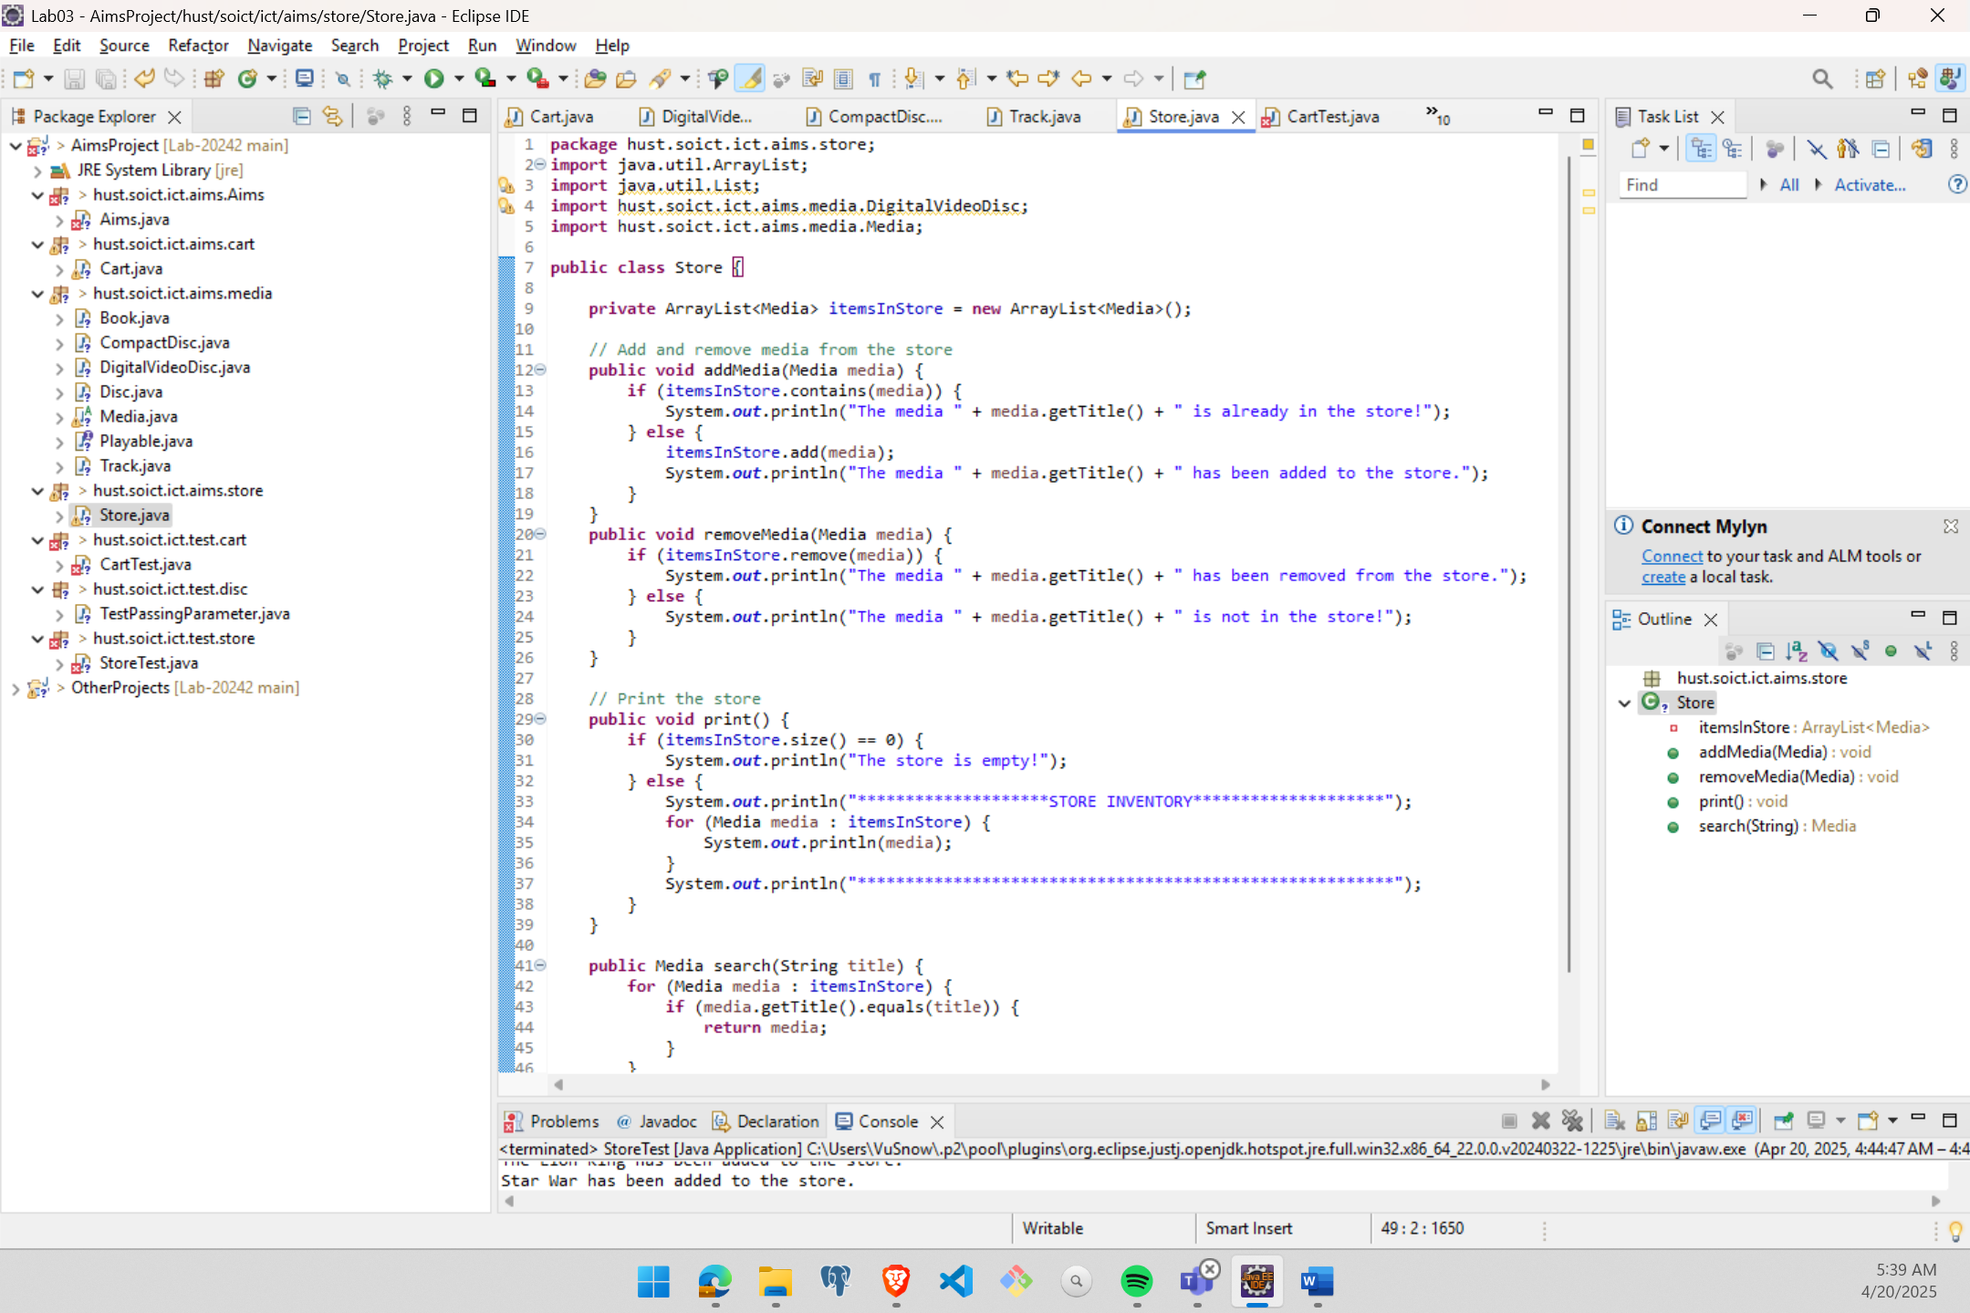

Figure : Store class after updating

# **Polymorphism with toString method**

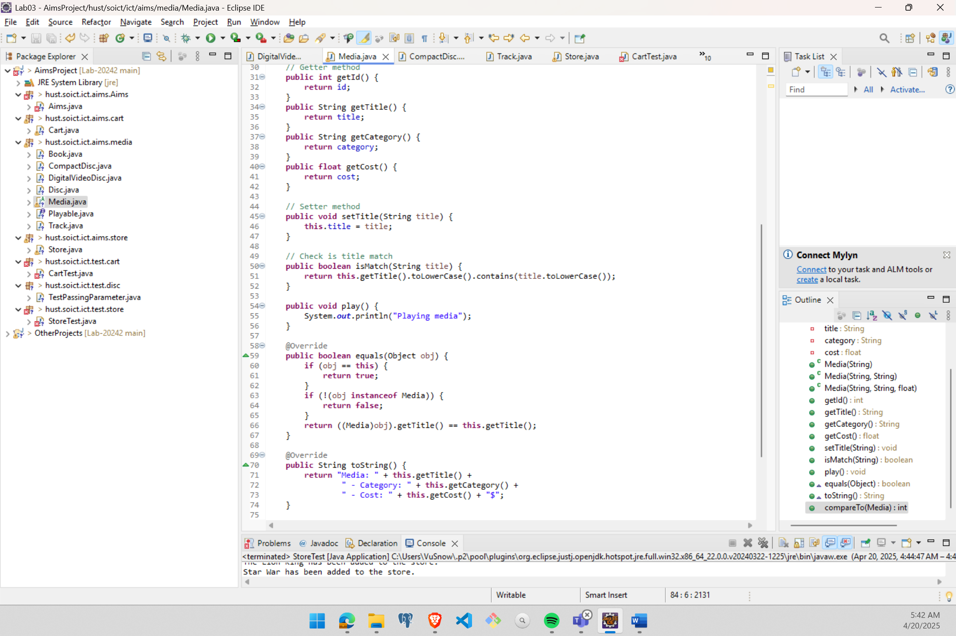

Figure : toString and equals

# **Sort media in the cart**

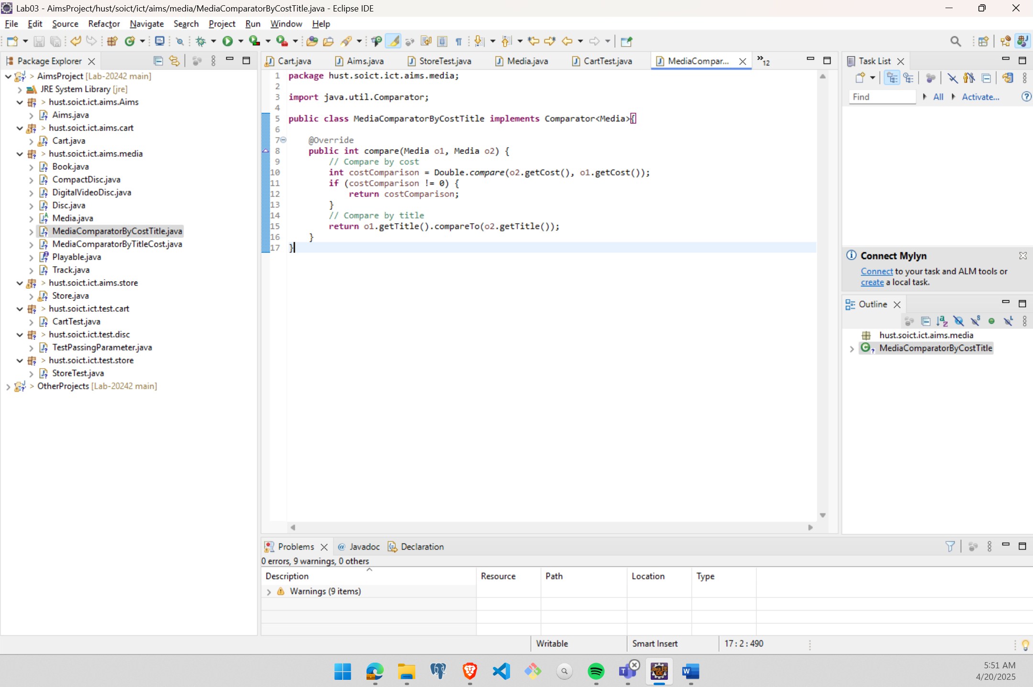

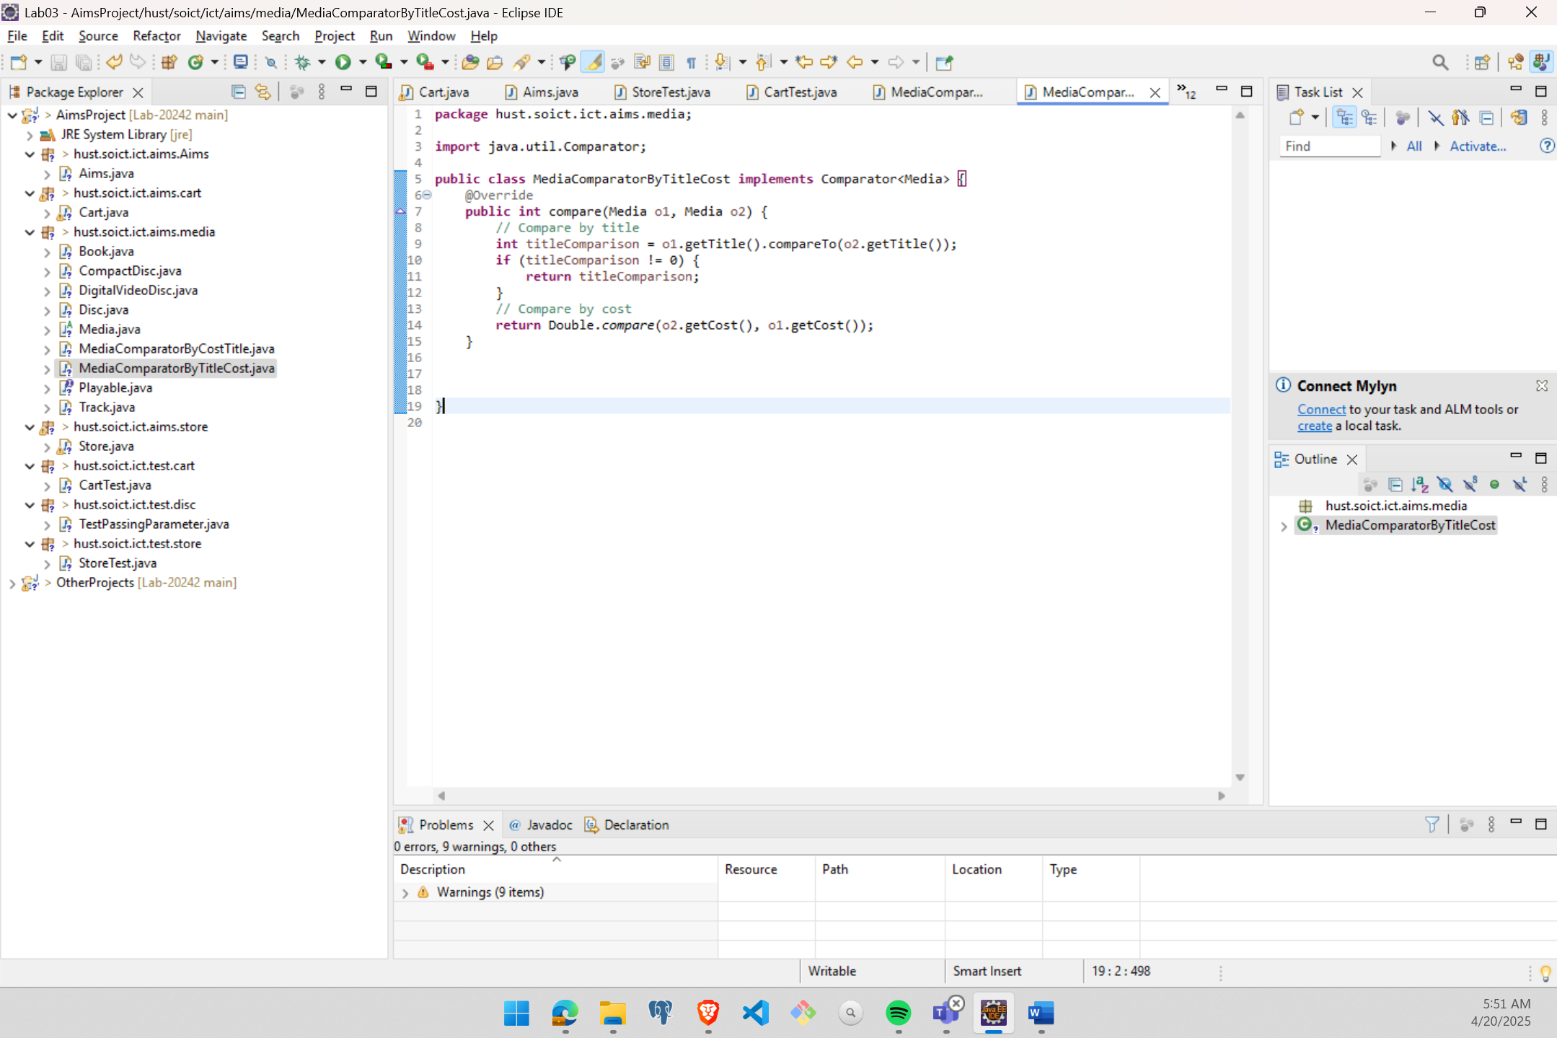

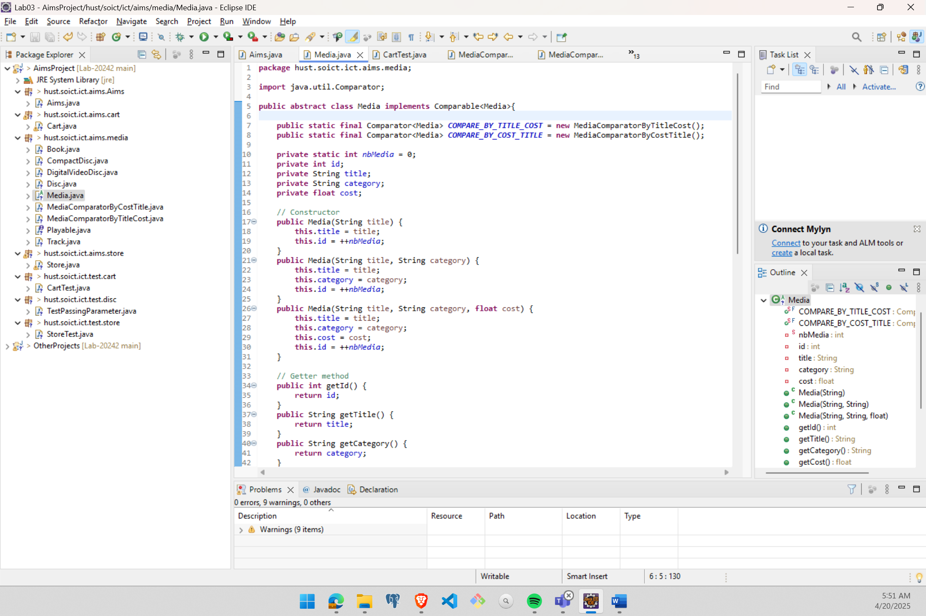

Figure : Implementing two comparator

* **Answer the question:**

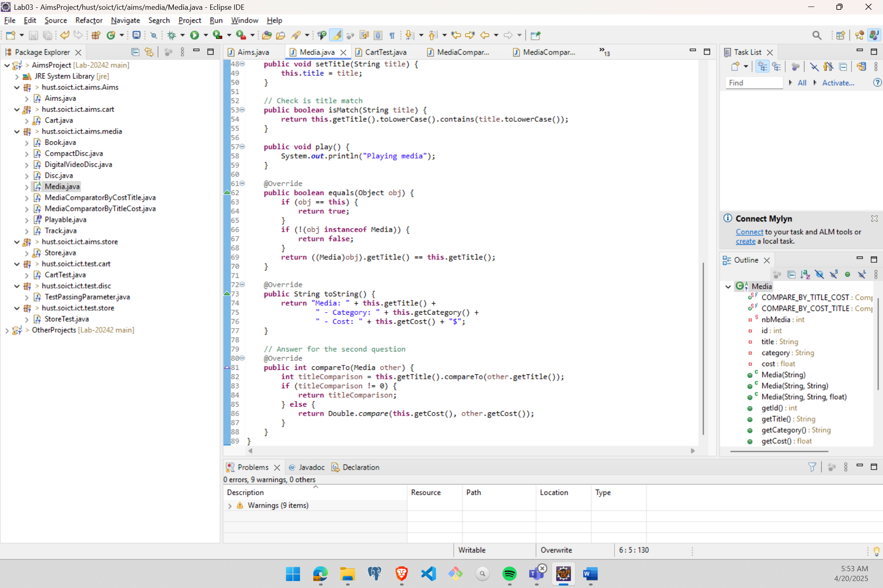

# **Create a complete console application in the Aims class**

* Full source code: **https://github.com/VuSnow/OOP-Lab-20242**